WVTMS Entry Form

**£10 entry fee – Please send with entry via cheque or cash.**

Name:………………………………………………………………………………………………………

Address:………………………………………………………………………………………………………………………………………………………………………………………………………………………

Tel No:………………………………………………………………………………………………………

Email:……………………………………………………………………………………………………….

Class:………………………………………………………………………………………………………..

Tractor & Plough inc. year of manafacture:..........…………………………………….

…………………………………………………………………………………………………………………

Member: Yes. / No

**IMPORTANT:**

I declare that I have read and agree to abide by the Society rules and that my entry will be covered by a Public Liability Insurance Policy, with a minimum indemnity of not less than **£1,000,000.** Certificates will be scrutinised prior to any entry being unloaded onto the field. Failure to produce a valid insurance certificate will result in entry refusal.

Insurance company: …………………………………………………………………………………

Policy No: …………………………………………………………………………………………………

Expiry Date: …………………………………………………………………………………………….

Signed:……………………………………………………………………………………………………

**Forms to be returned by 09th October 2020 to:**

Andy Bean, “Tarrants”, Vicarge Road, Napton on the Hill, Southam, CV47 8NA **OR** andybean53@hotmail.com

**Warwick Vintage Tractor & Machinery Society**

Vintage Qualifier 2021

Affiliated to the Society of Ploughmen

Ploughing Match

On

Saturday, 17th October, 2020

At

Oakley Wood Road

Bishops Tachbrook

Royal Leamington Spa

Warwickshire

CV33 9QH

Signposted off A425,

And B4100 (Banbury Road),

Fosse Way at Harwoods House,

Warwick.

By kind permission of

Mark Meadows

Organised by Bob Butlin (07917 193679)

Andy Bean (07749 651188 or 01926 817934)

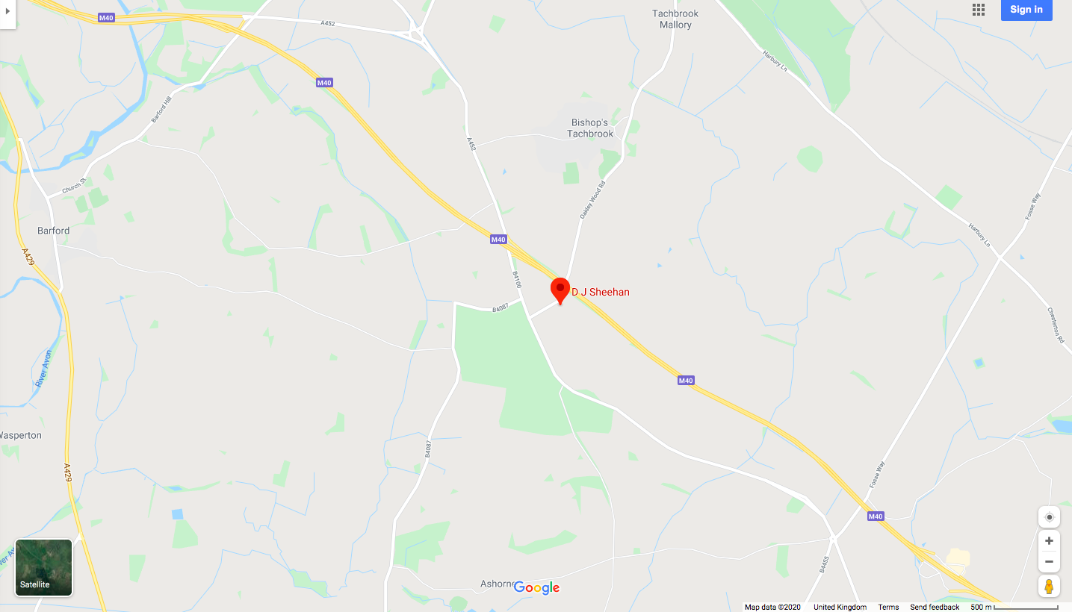

Ploughing Classes

10.00am Start – 2.00pm Finish

1. Open Qualifier Classic (Minimum depth 7 inches)
2. Members Classic
3. Open Qualifier Vintage Trailed
4. Members Vintage Trailed
5. Open Qualifier Vintage Mounted
6. Members Vintage Mounted
7. Novice
8. Ferguson TE20
9. Vintage One Furrow
10. Classic Reversible

Tractor & Plough Manafactured before 31/12/59

Tractor & Plough Manafactured before 31/12/59

Tractor & Plough Manafactured before 31/12/59

Ferguson Tractors & Ferguson plough

Those who have never been placed 1st

Tractor & Plough Manafactured before 31/12/59

Tractor & Plough Manafactured before 31/12/76

Tractor & Plough Manafactured 31/12/59 to 31/12/76